**Project Initialisation and Planning Phase**

| Date | 5th July 2024 |
| --- | --- |
| Team ID | 739719 |
| Project Name | Garment Workers Productivity Predictions |
| Maximum Marks | 3 Marks |

**Define Problem Statements (Customer Problem Statement Template):**

To develop a predictive model that accurately forecasts the productivity of garment workers based on various factors, aiming to optimise manufacturing efficiency and resource utilisation."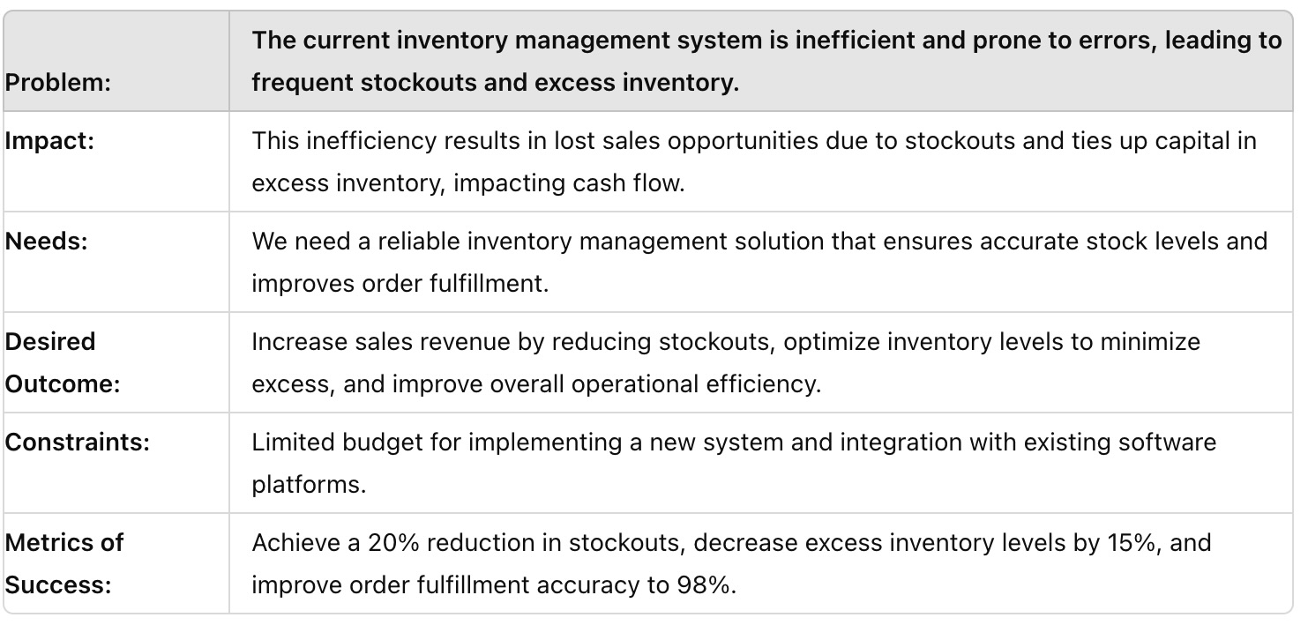

Reference: https://miro.com/templates/customer-problem-statement/

**Example:**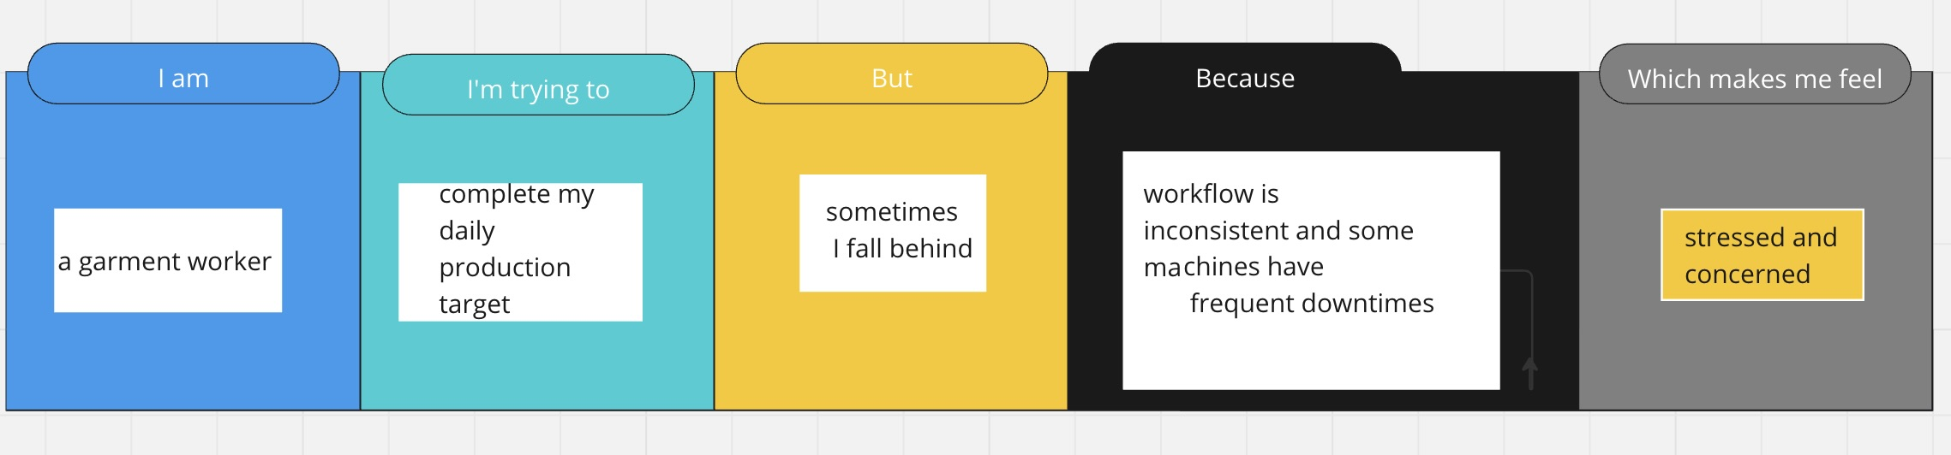

|  |  |  |  |  |  |
| --- | --- | --- | --- | --- | --- |
| **Problem**  **Statement (PS)** | **I am**  **(Customer)** | **I’m trying to** | **But** | **Because** | **Which makes me feel** |
| PS-1 | A garment factory manager | Accurately predict worker productivity | The current prediction model is not precise | It doesn’t account for all variables like worker skill levels and machine downtime | Frustrated and unable to optimise  Production schedule |
| PS-2 | An operations manager | Improve overall efficiency in the factory | Productivity  Predictions are often delayed | Data collection and processing take too long | Concerned about  meeting production  targets and deadlines |